DAD

Ok Well, Hi everybody. I welcome you all to today’s session.

Hello and welcome everyone. Let’s get started with today’s call.

Enterprise Release Management (ERM) is working on an IT wide initiative to improve the Application CICD Maturity scores.

We will focus mainly on the Release Automation scores (with a goal of 8% increase quarter over quarter) by the end of FY22.

Please note that this is a high priority IT wide initiative and the scores are reviewed quarterly in the CDO dashboard to check for progress.

Let me start with a brief overview of DAD tool. The purpose of this tool is to give Insights to development teams on their maturity to be classified as Devops.

There are three major areas which are assessed for maturity scoring and those are **CICI/CD Maturity,**

**Application** **Maturity** and **Team Contribution**.

If we drill down CI/CD Maturity we can see 6 key performance indicators which contribute to overall CI/CD score. These KPIs are evaluated across three different DevOps dimension (Build and Verify, Non-Prod Deploy & Validation and Prod Deploy and Validation).

As an Enterprise Release Management Team we are focused on Release Automation KPI. We are aiming to increase the score by 8% Quarter on Quarter (QOQ). For this we will set up meetings with the respective applications Dev managers/POCs and would help you out to increase the Maturity score.

There are four Maturity levels Maturity1, Maturity2, 3 and 4.

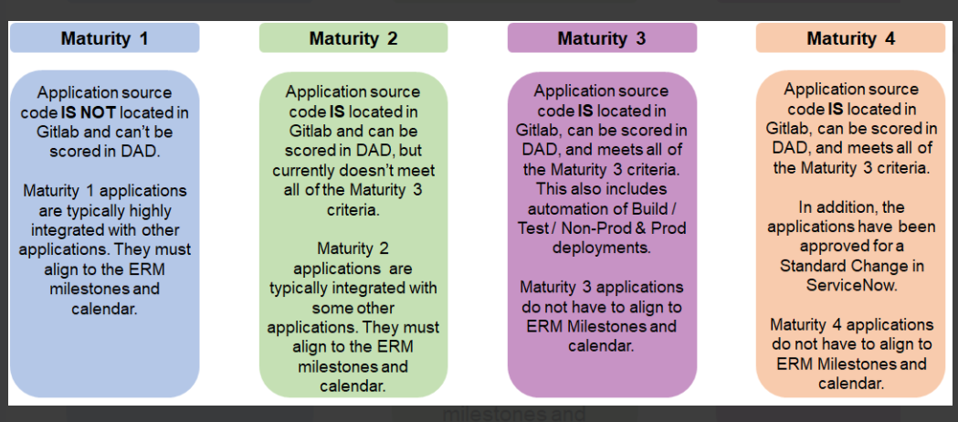

*?showUrls=true*

**YAML Files and Blueprints**

YAML file is basically the definition for your pipeline

Gitlab picks up your yaml file to see which of jobs to be run based on your attribute

We baseline all our expressions using Devops Blueprints

**Feedback topics:**

1. Check out type of Project
2. Keep Confluence links handy – thorough understanding
3. Check the deployment command expressions
4. Collect the details for new commands and check with support Team

List out Steps to increase Security Automation and Release Automationfor every project under your app.

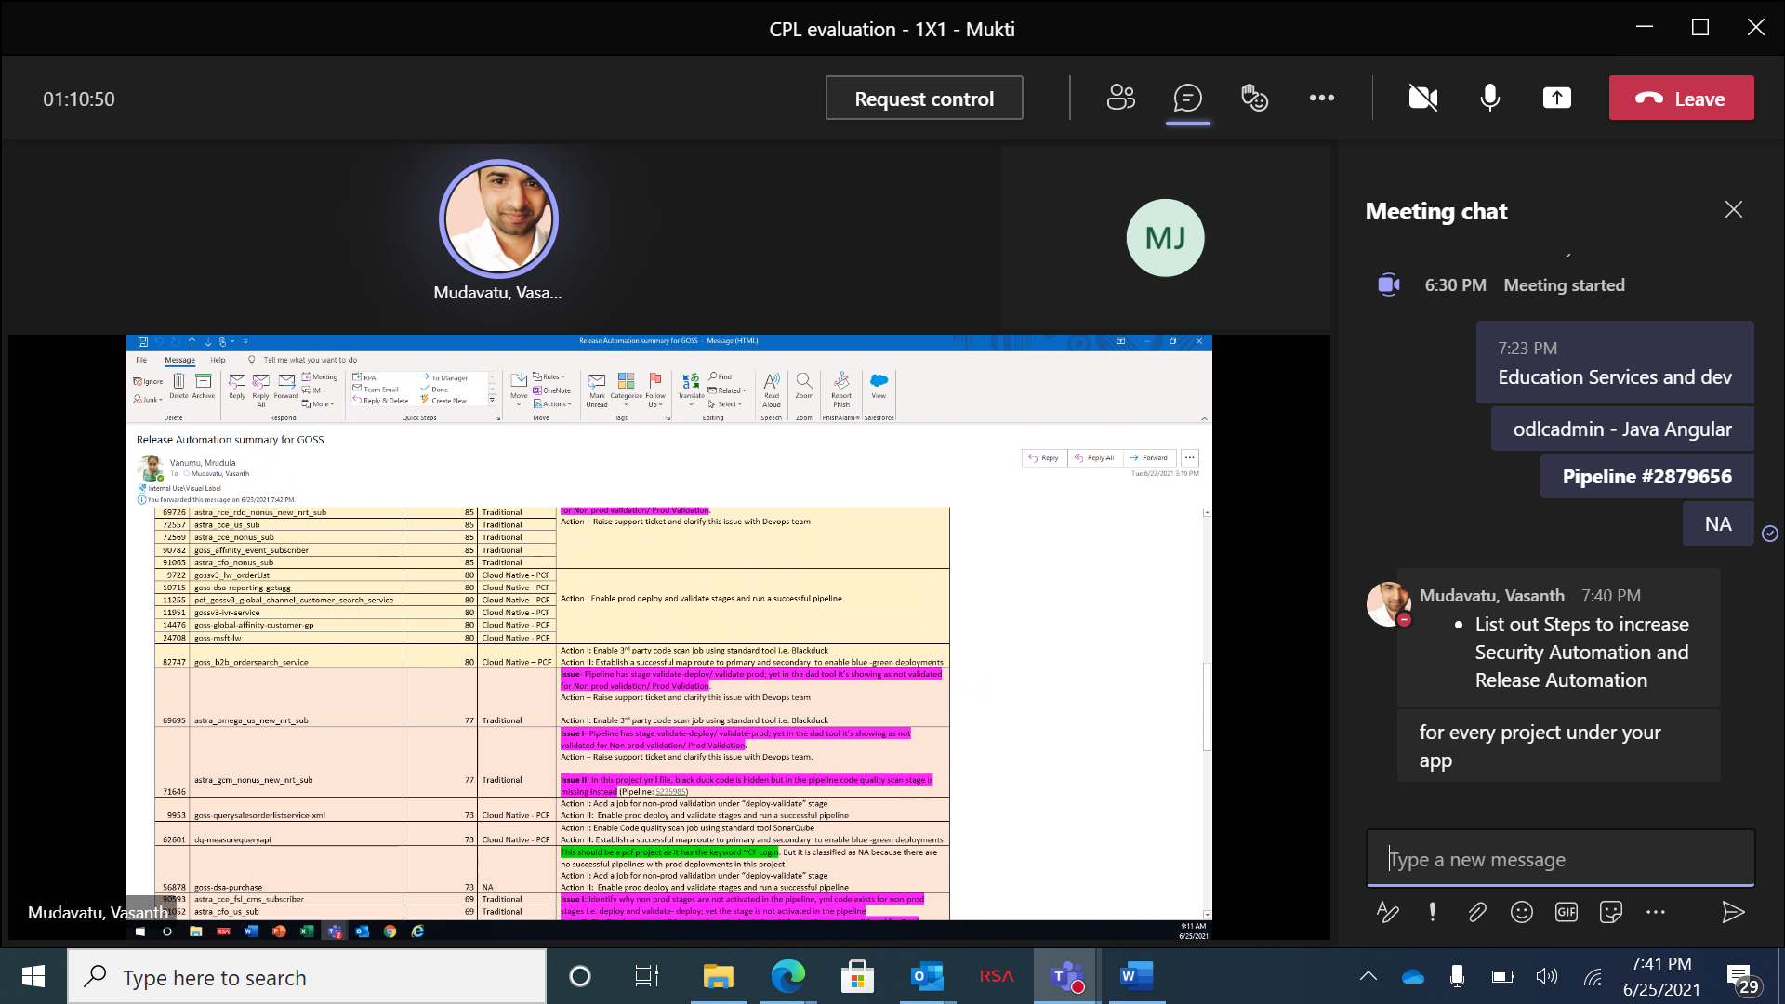

DAD widely used reports

Application Maturity score

Production Deployment Report

Application Project types score

2. POMA Maturity done at product level. DAD tool tracks and scores at Application level maturity

Middle ware - how are we tracking

Source code is in gitlab but the pipeline is in tfs, even they have automation process, full pipeline automated using tfs, maturity is much higher

Novora

Aptitude application